

**Template Manager v0.0.7 Instruction Manual**

Hello! This is the instruction manual for Template Manager, a tool for easily sorting and accessing templates needed throughout the workday!

**Setup:**

There is no setup! All you have to do is double-click the “TemplateManager.exe” to run!

It is important that the TemplateManger.exe file remain within the main Template Manager folder alongside the “Resources,” “Settings,” and “Templates” folders in order to operate successfully.

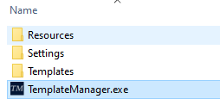

It is recommended that the Template Manager folder containing the application and sub-folders be placed in a directory like “Documents,” and then right-clicking the executable to create a shortcut which can be moved around as needed!

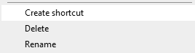

**Use:**

Simply click the button corresponding to a particular template! If it is a “Text” template, it will copy to your clipboard for easy pasting in other documents. If it is a “File” template, it will use your computer’s default selection to open the file, such as opening a new Email from an Outlook Template File.

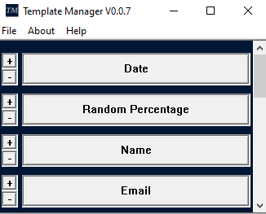

The “+” and “-“ keys allow you to shift buttons up or down. The manager Dynamically increases in size to accommodate more templates, and if no more can fit on the screen, it will generate a scrollbar to allow for infinitely more templates!

**The File Menu and Creating New Templates:**

The File Menu provides a few easy access options, including the ability to “Edit Templates.”

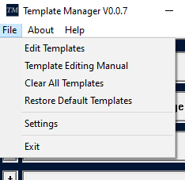

**Creating Templates:**

After hitting the “Edit Templates” button from the file menu, the “Template Editing Menu” is opened.

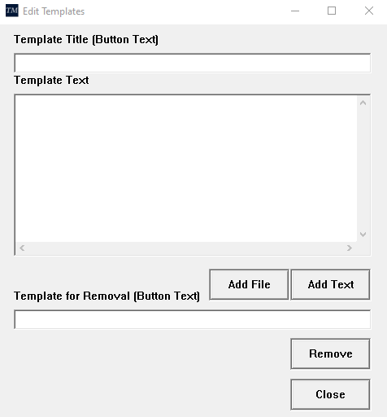

To create a “Text” Template, merely enter in a Title into the “Template Title” box, add the desired text into the “Template Text” box, and hit “Add Text.” This will make a new Template which copies the desired text to your clipboard when the template button is pressed in the Main Window.

The Template Title will be the primary way templates are recognized, and is the name displayed on the Main Window’s template buttons. **If a Template Title already exists, you can choose to overwrite the current template when hitting “Add Text” or “Add File.”**

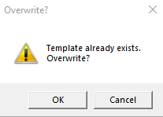

If the “Add File” button is pressed after a Template Title has been set, a “File” template can be created. This will ignore anything within the “Template Text” box, and instead open a standard Windows “Open File” dialogue window. Navigate to the desired file and select it to add it to the “File” template. Whenever that Template is selected, Windows will use its default application for the filetype to open the chosen file.

**Note: Windows does not always default to the best application.** As an example, PowerShell scripts default to Notepad.exe under most circumstances. Keep this in mind when creating “File” templates.

**Known Issues:** Copying templates from other applications, such as OneNote, into the “Template Text” box can introduce invisible errors due to differences in encoding. If you notice a Template is failing to add (or TemplateManager is crashing) when copying a template’s text from another location, it’s recommended the text be pasted to a simple text editor such as Notepad.exe first, and then copied from there into the Template Manager.

**Removing Templates**: To remove a template, simply enter the template’s title in the “Template for Removal” box, and hit Remove. This will remove the respective button from the Main Window.

**Text Templates and Flags:** Flags are simple items which can be placed into a “Text” Template to get a unique effect when clicking the Template button. Flags like [Date] or [Today] return the current date, while [Time] will include the time as of the button press. This is a simple way to add dynamic functionality to “Text” templates! The full list of available flags can be found in the File Menu under the “Template Editing Manual” button.

**Clear All and Restore All Templates**:

The Clear All and Restore All options from the File menu do exactly what they say, clearing all Templates currently in the manager, or restoring the templates to the default selection setup by your application provider.

**Settings:**

The Settings Menu, accessed from the File Menu’s “Settings” button, is used to set custom variables for a selection of “Text” template flags.

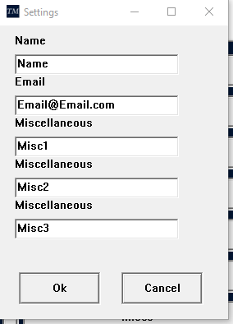

The [Name], [Email], [Misc1], [Misc2], and [Misc3] flags pull from the respective boxes. This can be a useful way to add often-used and often-changed entities to “Text” templates. As an example, if 10 Templates reference a particular email, but said email changes frequently, using the [Email] flag and setting allows all 10 templates to be changed from just the single setting window!

These variables are powerful tools for minimizing the work you need to do when updating templates!

On that note, this is the end of the instructions! Have fun with your Templates!